M S RAMAIAH INSTITUTE OF TECHNOLOGY

(Autonomous Institute affiliated to VTU, Belgaum)

MSR Nagar, Bangalore-560054



January to June 2016

Department of Computer Science & Engineering

**SYNOPSIS ON SINGLE PANE MANAGEMENT OF CLOUD EMAIL SECURITY**

Submitted by

**Kush Bavishi 1MS12CS049**

Under the guidance of

**S. Rajarajeswari**

Assistant Professor

**SINGLE PANE MANAGEMENT OF CLOUD EMAIL SECURITY**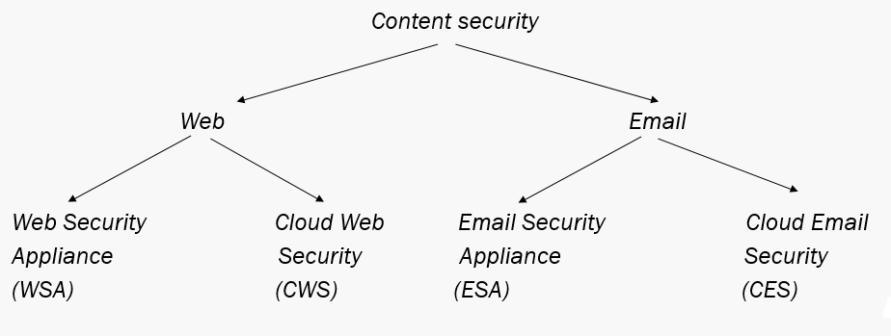

**Cisco Security – Engineering Division**

The team provides:

* + *Content based security*
  + *Network based security*

**Work Environment**

**Hardware Specification:**

* **Processor**  : Intel(R) Core(TM) i5-4310U CPU @ 2.30GHz
* **RAM** : 8.00 GB
* **System Type** : 64 bit Operating System

**Software Specification:**

* **Operating System** : Microsoft Windows 7 Enterprise
* **Languages** : Python, JavaScript, HTML 5
* **Technologies/Tools** : Internal Cisco tools, Virtual Machines (FreeBSD 9), Putty, Cisco internal reporting system.

**Project Definition**

* Objective : To build a single pane portal for both clients and internal use.
* The clients can be hosted on any cloud storage such as Azure or AWS.
* The single pane access provides the following functions:
  + *Configuration*
  + *Reporting*
  + *Monitoring*

**Terms and Acronyms**

* SMA – Security Management Appliance
  + - Used to connect ESAs
    - Acts as an aggregator.
* ESA – Email Security Appliance
  + - Each client has 2 ESAs in them.
    - There is a duplicate copy of each mails stored in ESAs.

**Impact of the Developed System**

The proposed system –

* + *Acts as a single pane window (dashboard) for multiple clients.*
  + *Provides easy access to monitoring and reporting.*
  + *Configurations can be updated for individual clients.*
  + *Client specific details provided.*
  + *Easy to maintain at a single point.*